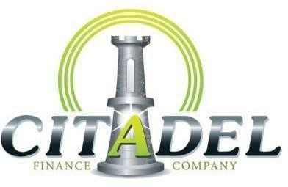

months = 19.99% 36 months = 20.99% 48 months = 21.99%

- 15% of Sales Price is minimum Down Payment or Trade equity including receipt or title.

- $12,500 is maximum amount financed including bank fee, plus gap and warranty. * no add for Silver any longer.

- 130% of NADA clean trade is max to finance plus gap and warranty. Can add up to $3000 to amount financed splitting each $1 with bank fee.

- 18% Max Payment to income. Overtime can be counted if more than a year on the job. SSI/Disability/Retirement CANNOT be grossed up.

- Customer Interview by GM/GSM and Job Verification.

- 6 References, Pay Stubs, verified full coverage insurance. Stable job time minimum 6 months (verified), and stable home environment (minimum 1 year). All income must verify. No self-employed.

- $250 minimum Payment/$450 Maximum Payment…All Payments are due on the 15th of the Month.

- Interrupter, spare key and $1500 minimum bank fee added to all deals (up to $3000 if increasing advance, bank fee refunded to Employees at time of Pay-off.

- Employees and returning Citadel customers receive a 4% rate reduction off rate card. If beacon over 680 (all applicants) rate is 13.99%.

- We do not finance ANY European cars.

- All regular drivers must be on loan, and insurance coverage, with valid driver’s license

- A vehicle MUST be Fortress or Silver Certified. A wrap may be added for a max of 2x cost of wrap.

- A $200 VSI fee included on all deals.

- Fortress Gap insurance may be added for $695 maximum.

- All Citadel Documents completely filled out: Checklist, Insurance, Reference Sheet, and Assignment form.

- • We do not finance ANY vehicles over 200,000 miles, European, Cadillac, Lincoln, or Chevrolet Cruze.

